Changes document for MS Decom activities.

Program: ZPMDBR_WPFIS_MASS_QIR_UPDATE

System: xEM

CD : CD152048- MS Decom xEM

Transport Request: DEMK931402

=======================================================

1. Modification logs in the program header.

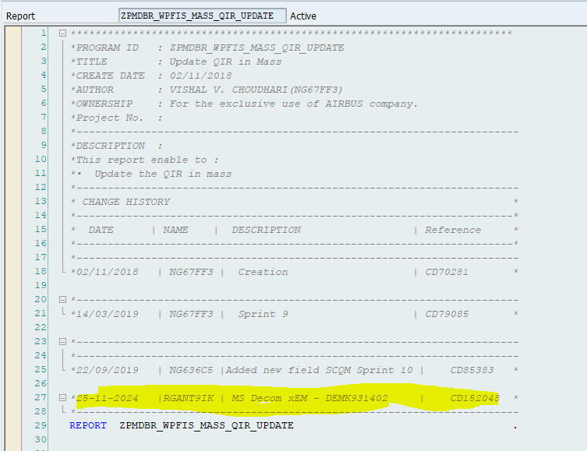

1. Adding a new parameter in selection screen to capture the google sheet url.

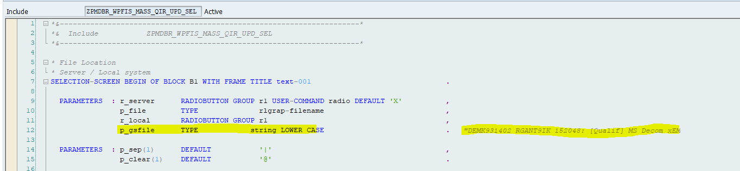

1. In upload_file form added below logic to read the gsheet data by using the FM - Z_4B1D_GSHEET2ABAP.

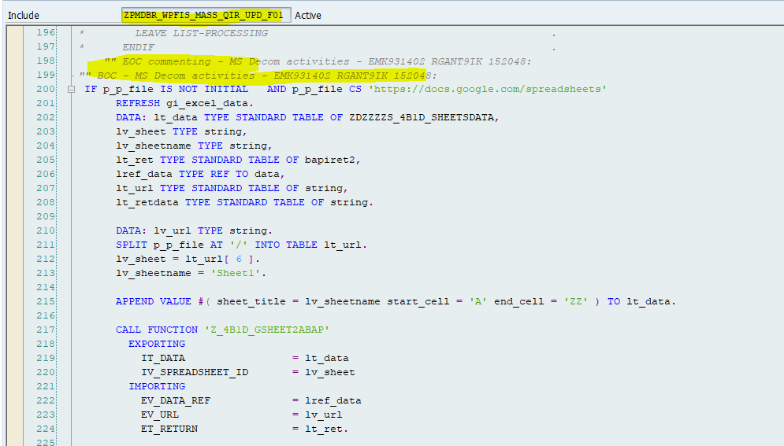

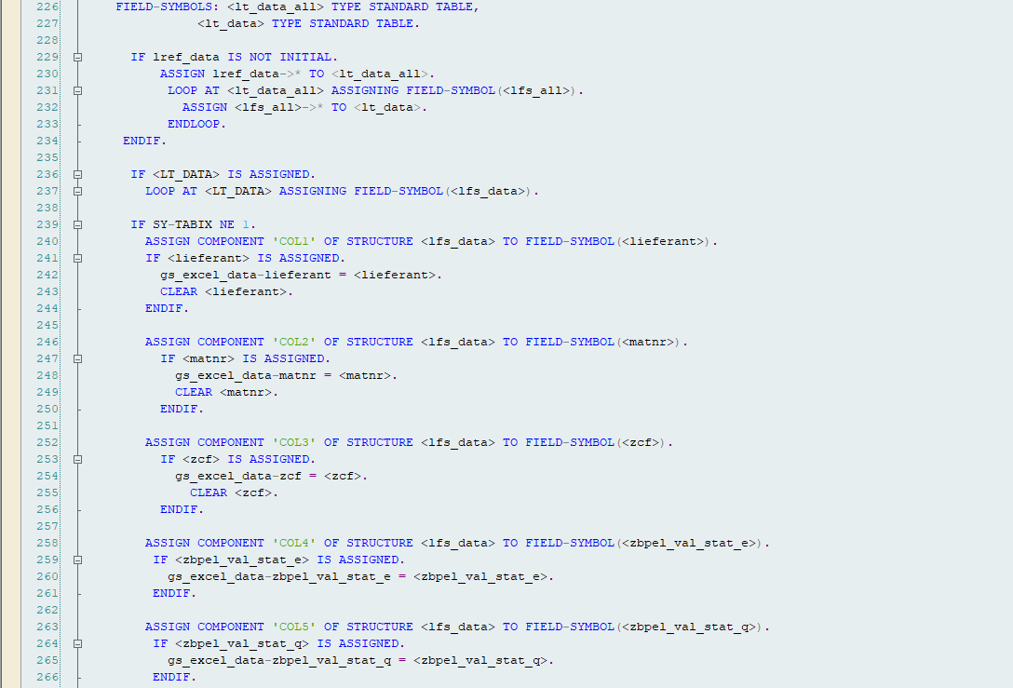

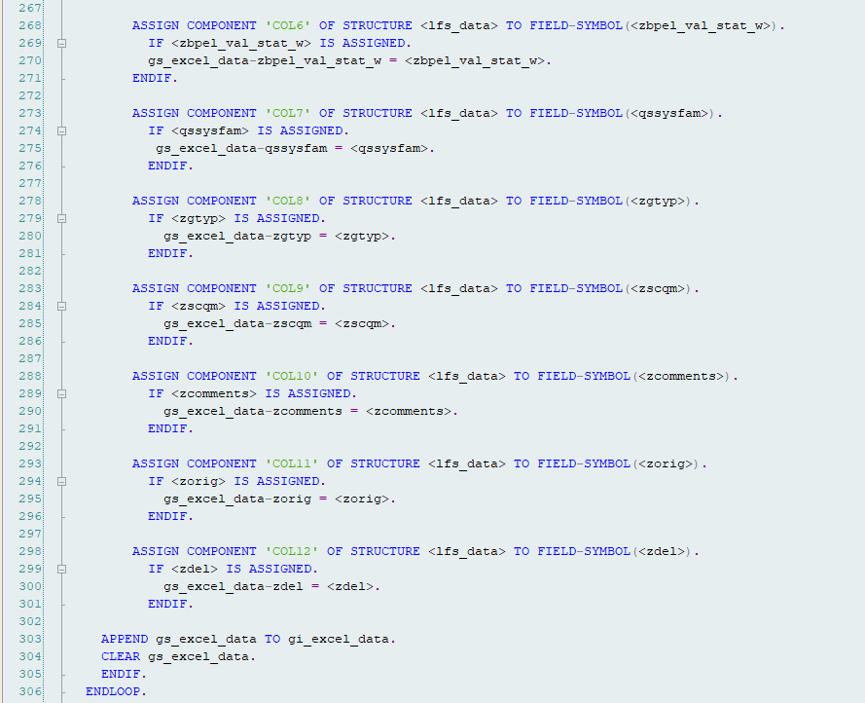

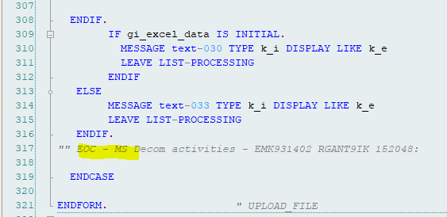

1. As mentioned in above screenshot logic - whole data from the gsheet will transfer into the gi_excel_data internal table.
2. Screen modification logic to disable gsheet url input field while selecting server upload option.

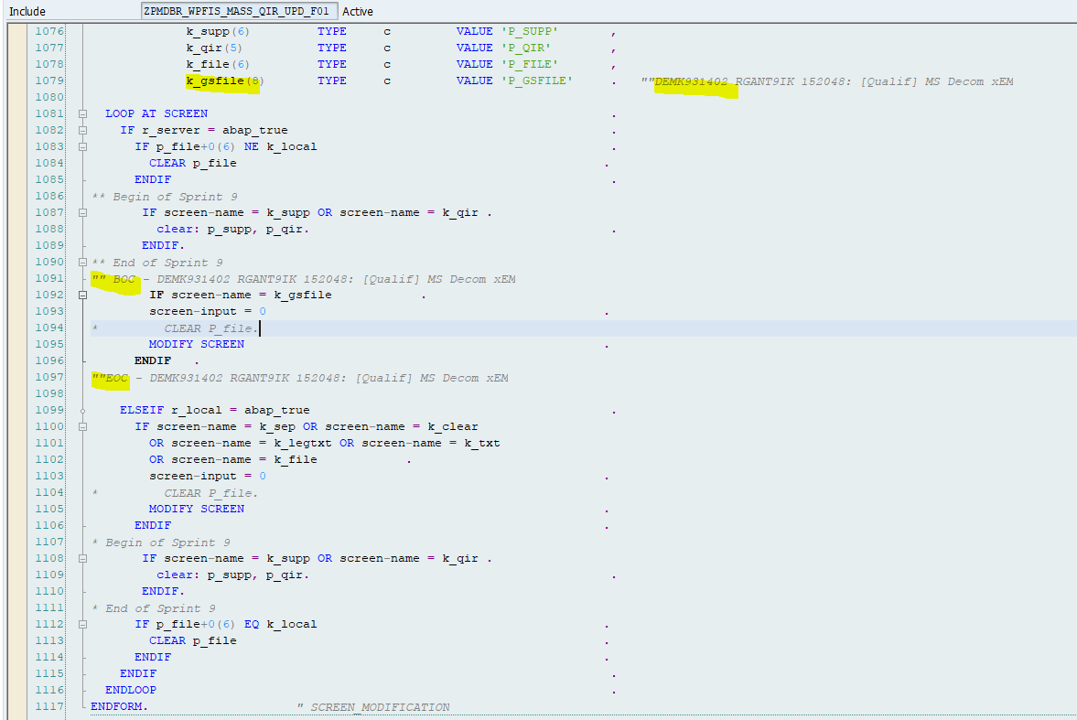

1. Based on the selecting file location - the respective url is getting passed to upload_file form to read the data and process it further.



